**Welcome to “New Product News”**

In an effort to keep ODOT up-to-date on the new products being evaluated by the department, New Product News serves to highlight some ongoing and completed evaluations and resulting specification modifications. This publication will be issued on regular basis. This document, as well as a list of approved materials can be found online at the [Office of Materials Management website](mailto:brad.young2@dot.ohio.gov).

If you have any comments/questions or have new product needs, please contact Brad Young [brad.young2@dot.ohio.gov](http://spinternetdev.dot.state.oh.us/Divisions/ConstructionMgt/Materials/Approved%20List/APL-Listing-Fog-Seal.pdf) or 614-351-2882.

**2016 New Product Highlights**

Completed Evaluations

1. Heat-Fused Preformed Thermoplastic Shield Pavement Markings were approved for use under [SS814](mailto:brad.young2@dot.ohio.gov) and [SS914](https://www.dot.state.oh.us/Divisions/Engineering/Geotechnical/Geotechnical_Documents/PRWS_Approval.pdf). (Photo below is an example)

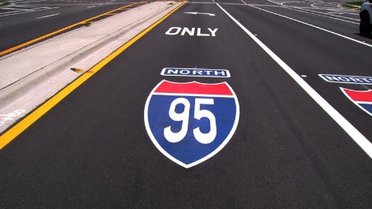

1. Items 626 and 726 were modified to include structurally reinforced, plastic guardrail reflectors like the one shown in the photo below. These should function better than the metal plates used in the past.

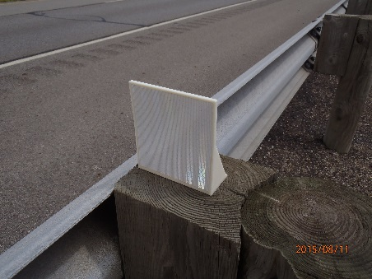

1. Item 705.03 Preformed Fillers was modified to include semi-rigid closed-cell polypropylene foam preformed fillers.

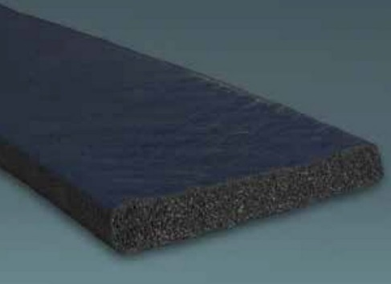

1. Temporary Portable Rumble Strips RoadQuake 2 and 2F – These products were approved by FHWA under a Public Interest Finding (PIF) dated 12/23/14 for five years. The intent of the product is to increase driver alertness and attention in work zones consisting of primarily one-lane, two-way flagging operations. Included in the following links are the [Approved List of Products](https://www.dot.state.oh.us/Divisions/ConstructionMgt/Materials/Pages/default.aspx), [Standard Construction Drawing MT-97.20](https://www.dot.state.oh.us/Divisions/Engineering/Roadway/DesignStandards/traffic/SCD/Documents/MT_09720_01-16-2015.pdf), and the required online [Internal Reporting Form](https://www.dot.state.oh.us/Divisions/ConstructionMgt/Materials/Pages/default.aspx).

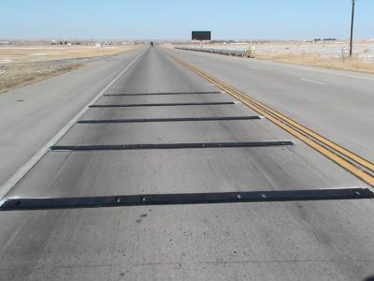

1. [Asphalt Emulsion Fog Seal](https://www.dot.state.oh.us/Divisions/ConstructionMgt/Specification%20Files/814_04152016_for_2016.pdf) – This fog seal would be placed over top of a chip seal.
2. [Prefabricated Retaining Wall Systems](mailto:brad.young2@dot.ohio.gov) were added to the Approved Listing (AL)

[](http://portal.dot.state.oh.us/divisions/communications/images/2011%20Construction%20Brochures/D9%20LAW-93C%20IR%20Bridge.jpg)

**Ongoing Evaluations**

The products listed below are currently installed and are under evaluation.

Milliken Concrete Cloth

Corrugated metal pipe culvert invert repair was done using this product. Product comes in 3 foot wide rolls, was cut to length, rolled into place, secured to the pipe wall, and saturated with water. Product hardens like concrete. The photo below is of a culvert repair done on BUT-732-0248. District 8 and OHE will monitor performance.

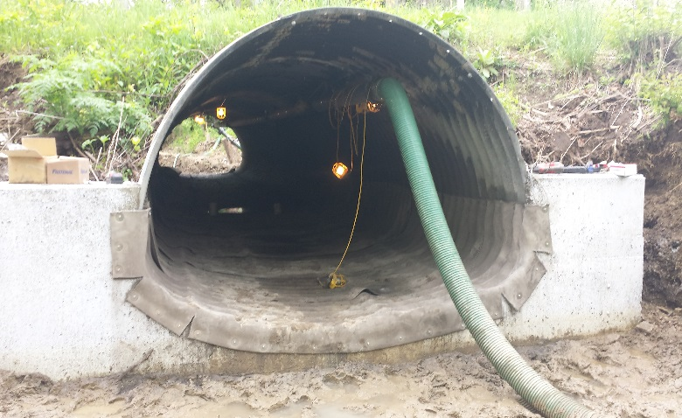

American Molded Plastics

This cable rail reflector clips onto the cable without any hardware. The test will be to see if they hold up to winter conditions that include thrown plowed snow. Product would compete with or replace the small reflective sheeting that is adhered to the posts.

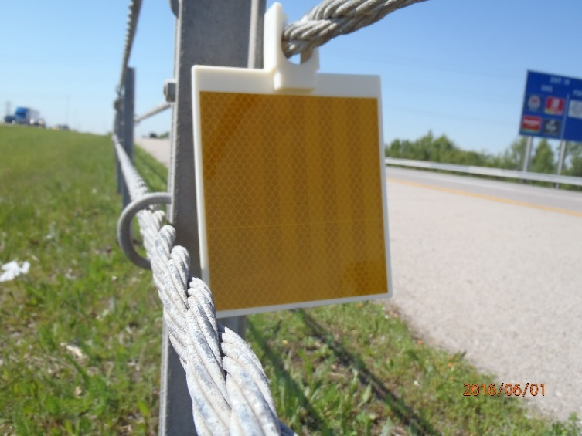

Longitudinal Joint Sealant – VRAM or J-Band

Premature failure of asphalt pavement often happens at the longitudinal joint. This asphalt emulsion is spayed 18 inches wide under this joint. It migrates into the mix above and increases the density and lowers the permeability at the joint. Ill DOT has had success with the product.

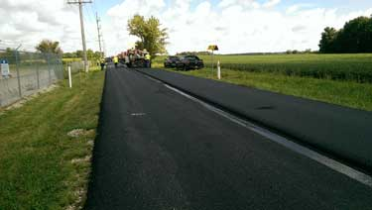

Island Radar Company

This product will be a substitute product for standard railroad preemption interface no longer available at CSX crossings. This product will be used on a project in District 6.

Sealing Gravel Shoulders

Two products are going to be tried in Dist. 5 to evaluate alternates to cutback asphalt for sealing gravel shoulders. One is called GreenStreet Asphalt from R&D Asphalt Products and the other is a Tall Oil Pitch from ENS Solutions.

Internally Illuminated Raised Pavement Markers (IIRPM)

A contract recently sold to evaluate these in several Districts. Several features of the device will be evaluated such as the visibility of the product in curves and the durability of the product to withstand snow plowing. If effective, the product has the potential to be used in other areas like wrong way crash locations, rural stop bars, and raised median identification.

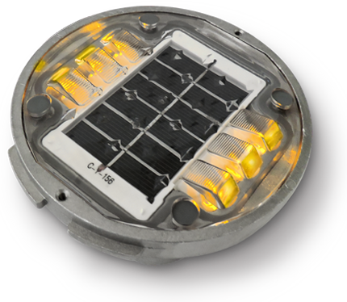



**Listing of other products submitted in 2016**

The products listed below are currently in some phase of development. For more information on these products, contact Brad Young [brad.young2@dot.ohio.gov](https://www.dot.state.oh.us/Divisions/Engineering/Roadway/TrafficControl/MOTRumble/Approved%20Temporary%20Portable%20Rumble%20Strips%20-%204-10-15.pdf) or 614-351-2882.

|  |  |  |
| --- | --- | --- |
| **MANUFACTURER** | **PRODUCT NAME** | **DESCRIPTION** |
| American Pavements / Asphalt Materials | Scrub seal | Pavement preservation treatment / interlayer. Same as chip seal, but emulsion is broomed into pavement |
| BP Composites | GFRP rebar | Glass fiber reinforced plastic rebar |
| Bridge Preservation, LLC | Bridge Deck Membrane | Spray applied bridge deck waterproofing membrane |
| Cargill | Anova 1815 | Shifts PG grade, rejuvenates RAP/RAS mixes |
| Environmental Energy Solutions | UltraBond | Dust control |
| Meadow Burke | Tuff Plus Slab Bolster | Plastic rebar support |
| Professional Pavement Products | Median-Alert | Raised median reflective alert system |
| Sherwin Williams | Sherflex | Spray applied polyurethane pipe liner |
| SolarBright | PATEYE | Solar powered RPM - uses blue light to indicate when frost/freeze conditions exist |
| Tensar | TriAx TX5 Geogrid | Polypropylene subgrade reinforcement grid |
| The Fischer Group | Cure Right | Concrete cure membrane |
| Trinity Highway | QuadGuard Elite M10 | Redirective, non-gating crash cushion |

This document, as well as a list of approved materials can be found online at the [Office of Materials Management website](https://www.dot.state.oh.us/Divisions/ConstructionMgt/Specification%20Files/914_04152016_for_2016.pdf).

Remember, if you have any comments/questions or have new product needs, please contact Brad Young [brad.young2@dot.ohio.gov](http://portal.dot.state.oh.us/Divisions/Operations/MaintAdmin/Pages/Rumble_Strip_Reporting.aspx) or 614-351-2882.

[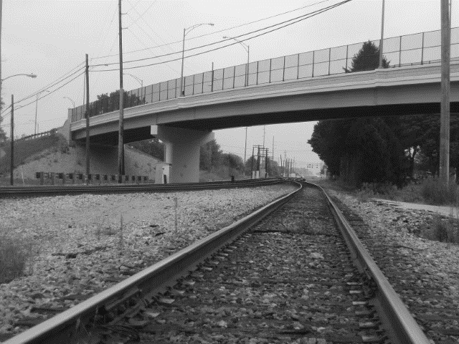](http://portal.dot.state.oh.us/divisions/communications/images/Photo%20Week/District%2003/Picture%20204.jpg)